Digital Calculator Tinkercad Simulation & Arduino Programming

Project Overview
This project explains the design and working of a Digital Calculator using Arduino Uno, simulated in Tinkercad. The calculator performs basic arithmetic operations such as Addition, Subtraction, Multiplication, and Division using a keypad for input and an LCD display for output.

1. Objectives
- To design a calculator circuit using Arduino and peripheral components.
- To understand keypad interfacing and LCD display control.
- To implement basic arithmetic operations using Arduino programming.
- To test and verify calculator functionality in Tinkercad.

2. Introduction
A digital calculator is an electronic device used to perform mathematical calculations. In this project, Arduino Uno acts as the processing unit, the keypad is used to enter numbers and operators, and a 16×2 LCD displays the input and result. This project helps students understand embedded systems and human–machine interfacing.4

3. Block Diagram

Overall system flow is show below:
+-------------------+
| |
| 4×4 KEYPAD |
| (Numbers & Ops) |
| |
+---------+---------+
|
| Key Press Data
v
+-------------------+
| |
| ARDUINO UNO |
| (Processing & |
| Calculation) |
| |
+---------+---------+
|
| Result Data
v
+-------------------+
| |
| 16×2 LCD |
| DISPLAY |
| |
+-------------------+

BLOCK DIAGRAM EXPLANATION

1. Keypad (Input Unit)
- Used to enter numbers (0–9)
- Used to enter operators (+, −, ×, ÷)
- Sends key signals to the Arduino

2. Arduino Uno (Control & Processing Unit)
- Reads keypad inputs
- Stores first number, second number, and operator
- Performs calculation using program logic
- Sends the final result to LCD display

3. LCD Display (Output Unit)
- Displays entered numbers
- Displays selected operator
- Displays final calculated result

4.Components
Name | Quantity | Component
U2 | 1 | LCD 16 x 2
U1 | 1 | Arduino Uno R3
KEYPAD1 | 1 | Keypad 4x4
R1 | 1 | 1 kΩ Resistor

5.Wiring and Pin Diagram

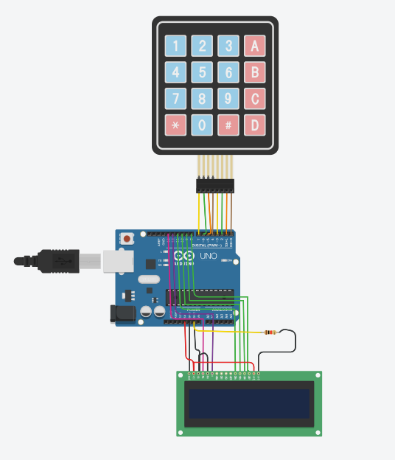
- The keypad rows and columns are connected to Arduino digital pins.
- The LCD RS, EN, D4–D7 pins are connected to Arduino digital pins.
- Potentiometer middle pin is connected to LCD V0 for contrast adjustment.
- LCD VCC and GND are connected to 5V and GND respectively.

Pin Configuration

Keypad Connections
Keypad Pin | Arduino Pin
R1–R4 | D9–D6
C1–C4 | D5–D2

LCD Connections
LCD Pin | Arduino Pin
RS | D13
EN | D12
D4–D7 | D11–D8

6.Building Circuits in Tinkercad
- User enters numbers and operators using the keypad.
- Arduino reads key presses and stores operands.
- When the equals key is pressed, Arduino performs the selected operation.
- The result is displayed on the LCD screen.

7. Arduino code
#include <Keypad.h>
#include <Wire.h>
#include <LiquidCrystal.h>

LiquidCrystal lcd(13, 12, 11, 10, 9, 8);

long first = 0;
long second = 0;
double total = 0;

char customKey;
const byte ROWS = 4;
const byte COLS = 4;

char keys[ROWS][COLS] = {
{'1','2','3','+'},
{'4','5','6','-'},
{'7','8','9','*'},
{'C','0','=','/'}
};
byte rowPins[ROWS] = {7,6,5,4}; //connect to the row pinouts of the keypad
byte colPins[COLS] = {3,2,1,0}; //connect to the column pinouts of the keypad

//initialize an instance of class NewKeypad
Keypad customKeypad = Keypad( makeKeymap(keys), rowPins, colPins, ROWS, COLS);

void setup()
{
lcd.begin(16, 2); // start lcd
for(int i=0;i<=3;i++);
lcd.setCursor(0,0);
lcd.print("Calculator");
lcd.setCursor(0,1);
lcd.print("by Shahmir Ahmed");
delay(4000);
lcd.clear();
lcd.setCursor(0, 0);
}

void loop()
{

customKey = customKeypad.getKey();
switch(customKey)
{
case '0' ... '9': // This keeps collecting the first value until a operator is pressed "+-*/"
lcd.setCursor(0,0);
first = first * 10 + (customKey - '0');
lcd.print(first);
break;

case '+':
first = (total != 0 ? total : first);
lcd.setCursor(0,1);
lcd.print("+");
second = SecondNumber(); // get the collected the second number
total = first + second;
lcd.setCursor(0,3);
lcd.print(total);
first = 0, second = 0; // reset values back to zero for next use
break;

case '-':
first = (total != 0 ? total : first);
lcd.setCursor(0,1);
lcd.print("-");
second = SecondNumber();
total = first - second;
lcd.setCursor(0,3);
lcd.print(total);
first = 0, second = 0;
break;

case '*':
first = (total != 0 ? total : first);
lcd.setCursor(0,1);
lcd.print("*");
second = SecondNumber();
total = first * second;
lcd.setCursor(0,3);
lcd.print(total);
first = 0, second = 0;
break;

case '/':
first = (total != 0 ? total : first);
lcd.setCursor(0,1);
lcd.print("/");
second = SecondNumber();
lcd.setCursor(0,3);

second == 0 ? lcd.print("Invalid") : total = (float)first / (float)second;

lcd.print(total);
first = 0, second = 0;
break;

case 'C':
total = 0;
lcd.clear();
break;
}
}

long SecondNumber()
{
while( 1 )
{
customKey = customKeypad.getKey();
if(customKey >= '0' && customKey <= '9')
{
second = second * 10 + (customKey - '0');
lcd.setCursor(0,2);
lcd.print(second);
}

if(customKey == '=') break; //return second;
}
return second;
}

8.Code explanation

1. Libraries
- Keypad.h → Read keypad input.
- LiquidCrystal.h → Control the 16x2 LCD.

2. Variables
- first → stores first number.
- second → stores second number.
- total → stores result.
- customKey → stores the pressed key.

3. Keypad Setup
- keys[4][4] → defines keypad layout.
- rowPins & colPins → define Arduino pins for keypad.
- customKeypad → object to read key presses.

4. LCD Setup
- Displays welcome message on start, then clears for input.

5. Main Loop
- Reads key pressed (customKey).
- If number (0-9): build first or second.
- If operator (+,-,*,/): call SecondNumber(), compute result, display.
- If =: finish second number input.
- If C: clear all and reset.

6. SecondNumber()
- Loops to collect digits for the second number until = is pressed.

Flow: Input first number → operator → second number → = → display result → repeat or clear with C.

9. Testing & Debugging
- Verify correct keypad key detection.
- Check LCD display clarity using potentiometer.
- Test all arithmetic operations.
- Reset calculator using the clear key.

10. Applications
- Educational projects
- Embedded systems learning
- Basic arithmetic devices

11. Advantages
- Simple design
- Low cost
- Easy to simulate and implement

12. Conclusion
This project successfully demonstrates a digital calculator using Arduino. It helps students understand keypad interfacing, LCD control, and basic arithmetic logic using microcontrollers.-
Link:https://www.tinkercad.com/things/jFMhuFQzmOD-epic-wluff?sharecode=5FTfLIVD4NPPxyGkr5IS_BFPZK7jYqQXCcqB8LyEb_w

